Customer Churn Analysis & Prediction System
A Project Report submitted
In partial fulfillment of the requirements for the degree of
BACHELOR OF COMPUTER APPLICATIONS
Under the
Guidance of
Mr. Bhuvnesh Kumar Sharma
(Assistant Professor)
Computer Applications Department
Submitted by:
Shashank Meshram (2315220038)



Department of Computer Applications
COLLEGE OF SCIENCE AND TECHNOLOGY
SURAJMAL UNIVERSITY
(Affiliated to Surajmal University) Kichha, U.S.Nagar,Uttarakhand-263148
May 2026
Certificate of Originality

We hereby certify that the work being presented in the BCA Major Project Report entitled "Customer Churn Analysis & Prediction System", in partial fulfillment of the requirements for the award of the Bachelor of Computer Applications and submitted to the Department of Computer Applications, Surajmal College of Science and Technology, Surajmal University, Kichha, Uttarakhand, is an authentic record of our own work carried out during a period from February 2026 to May 2026 (6th Semester) under the supervision of Mr. Bhuvnesh Kumar Sharma (Assistant Professor), Computer Applications Department.

If any plagiarism is found, none of my guide or anybody shall be responsible only I shall be responsible for the above-mentioned Project Report.

Shashank Meshram
Roll No.: 2315220038

This is to certify that the above statement made by the student is correct to the best of my knowledge.

Date:
Mr. BHUVNESH KUMAR SHARMA
(Assistant Professor)
Computer Applications Department
Project Guide
External Examiner

Department of Computer Applications
(Head of Department / Dean)
Abstract

Customer churn, defined as the discontinuation of service by a customer, represents one of the most pressing challenges in the telecommunications industry. In a market characterised by intense competition and abundant consumer choice, retaining existing customers is far more cost-effective than acquiring new ones, with research indicating that customer acquisition can cost five to seven times more than retention. Consequently, proactive identification of customers likely to churn has become a critical business intelligence priority.

This project presents the design, development, and deployment of a complete Customer Churn Analysis and Prediction System, built as a final year BCA major project. The system is developed using Python as the core programming language and uses the IBM Telco Customer Churn dataset — a publicly available benchmark dataset containing records of 7,043 telecom service subscribers described by 21 attributes. The dataset is stored in a MySQL relational database and accessed programmatically through Python.

The system implements a seven-stage data science pipeline: database connectivity and data loading, exploratory data analysis (EDA), data preprocessing, machine learning model training, model evaluation, visual analytics generation, and Flask web application deployment. Three supervised classification algorithms are trained and compared — Logistic Regression, Random Forest Classifier, and Gradient Boosting Classifier. The best-performing model, Logistic Regression with an accuracy of 80.38%, is serialised and deployed within the web application.

The Flask-based web application delivers three functional modules: a live analytics dashboard with key performance indicators and churn analysis charts; a real-time prediction interface accepting customer profiles and returning churn probability; and a JSON data endpoint for programmatic access. Key analytical findings reveal that month-to-month contract customers churn at 42.7%, senior citizens at 41.7%, and electronic cheque users at 45.3%, providing actionable insights for business retention strategy development.

Acknowledgment

I am grateful to Dr.(Prof.) Deepak Raj Sharma, Dean, Surajmal University, Kichha (Uttarakhand), for providing this opportunity to carry out the project "Customer Churn Analysis & Prediction System".

I would like to express my gratitude to the faculty members of the Department of Computer Applications, Surajmal University, Kichha (Uttarakhand) for providing academic inputs, guidance and encouragement throughout this period.

My sincere thanks go to Mr. Bhuvnesh Kumar Sharma (Assistant Professor), Computer Applications Department, who has given full effort in guiding and achieving the goal, as well as his encouragement to maintain my progress on track throughout the development of this project.
I would also like to thank my family and friends for their continuous moral support and encouragement throughout the duration of this project.
Finally, I express my indebtedness to all who have directly or indirectly contributed to the successful completion of this project.

Table of Contents

Contents Page No.

Certificate of Originality i
Abstract ii
Acknowledgment iii
Table of Contents iv
List of Figures v
List of Tables vi

Chapter 1: Introduction and Problem Statement 1
1.1 Background and Context 1
1.2 Problem Statement 2
1.3 Scope of the Project 2

Chapter 2: Literature Review 4
2.1 Churn Prediction in Telecommunication 4
2.2 Machine Learning Approaches 4
2.3 Research Gap and Project Contribution 5

Chapter 3: Methodology and System Design 7
3.1 System Architecture 7
3.2 Data Flow Diagram 8
3.3 Database Design 9
3.4 Pipeline Design 11

Chapter 4: Implementation 12
4.1 Development Environment and Project Structure 12
4.2 Database Connection Module 13
4.3 Exploratory Data Analysis 14
4.4 Data Preprocessing 16
4.5 Model Training and Selection 17
4.6 Model Evaluation 18
4.7 Visualisation Module 19
4.8 Flask Web Application 21

Chapter 5: Results and Analysis 23
5.1 Model Performance Results 23
5.2 Key Analytical Findings 23
5.3 Web Application Screenshots 24

Chapter 6: Conclusion and Future Scope 26
6.1 Conclusion 26
6.2 Limitations 27
6.3 Future Scope 27

References 28
Appendices 29

List of Figures
Figure 3.1 System Architecture Diagram 7
Figure 3.2 Data Flow Diagram (Level 0 — Context Diagram) 8
Figure 3.3 Data Flow Diagram (Level 1 — Detailed) 9
Figure 4.1 Project File Structure in VS Code Explorer 13
Figure 4.2 MySQL Workbench — Customers Table Schema 14
Figure 4.3 Churn Distribution Bar Chart (eda.py output) 15
Figure 4.4 Tenure Distribution Histogram by Churn 15
Figure 4.5 Preprocessing Pipeline Flowchart 16
Figure 4.6 Model Accuracy Comparison — Three Classifiers 18
Figure 4.7 Confusion Matrix — Logistic Regression 19
Figure 4.8 Churn Overview and Demographics Chart 20
Figure 4.9 Churn by Services Chart 20
Figure 4.10 Flask Application Route Structure Diagram 22
Figure 5.1 Flask Dashboard — KPI Metric Cards 24
Figure 5.2 Flask Dashboard — Visual Analysis Charts 24
Figure 5.3 Prediction Form Page (/predict) 25
Figure 5.4 Prediction Result Page with Probability Bar 25
List of Tables
Table 2.1 Comparison of Related Works in Churn Prediction 6
Table 3.1 Customers Table — Column Definitions (21 Columns) 9
Table 3.2 Pipeline Design 11
Table 4.1 Software Dependencies and Versions 12
Table 4.2 Dataset Summary Statistics 14
Table 4.3 Categorical Columns and Encoding Strategy 16
Table 4.4 Machine Learning Model Accuracy Comparison 18
Table 4.5 Classification Report — Logistic Regression 18
Table 5.1 Churn Rate by Contract Type 23
Table 5.2 Churn Rate by Payment Method 23
Table 5.3 Churn Rate by Demographics 24
Table 6.1 Future Enhancements Roadmap 27
Chapter 1
Introduction and Problem Statement
1.1 Background and context

The telecommunications industry operates in one of the most competitive environments in the global economy. With the rapid proliferation of mobile internet services, satellite broadband, and over-the-top communication platforms, customers now have an unprecedented range of service alternatives at their fingertips. This intensely competitive landscape has transformed customer retention from a routine business function into a core strategic priority.
Customer churn — the phenomenon whereby customers discontinue their use of a company's services — is the most direct measure of a business's ability to retain its customer base. In the telecom sector, monthly churn rates typically range between 1.5% and 3.5%, with annual churn reaching 20–30% for some service providers. Given that the lifetime value of a retained customer is significantly higher than the cost of acquiring a new one, even marginal improvements in churn prediction accuracy can translate into substantial preserved revenue.

Traditional approaches to churn management relied on customer satisfaction surveys, call centre escalation patterns, and heuristic business rules derived from the experience of account managers. However, the scale of modern telecom operations — with customer bases numbering in the millions — renders such approaches impractical and insufficiently precise. The emergence of machine learning and data science methodologies has fundamentally transformed this domain, enabling companies to identify at-risk customers proactively and at scale.

This project — developed as the Major Project for the Bachelor of Computer Applications (BCA), 6th Semester — implements a complete, end-to-end data science solution that integrates exploratory analysis, machine learning-based prediction, and an interactive web application to deliver churn intelligence directly to business users.

1.2 Problem Statement

Despite the availability of rich customer behavioural data, most organisations lack a centralised, automated system that can perform the following tasks effectively:
- Systematically analyse historical customer data to identify churn patterns across demographic, service, and billing dimensions.
- Train, compare, and deploy machine learning classification models to predict individual customer churn probability with measurable accuracy.
- Present analytical findings and predictions through an accessible web-based interface that does not require the end user to possess programming or statistical knowledge.
- Store and query large volumes of customer data efficiently using a relational database management system.

The absence of such an integrated system means that even when data is available, its predictive value remains unrealised. Business analysts rely on static reports, and retention teams operate reactively rather than proactively — contacting customers only after they have already initiated the process of leaving.

This project addresses these deficiencies by building a modular, end-to-end system that automates the complete churn analysis and prediction pipeline — from raw database data to a live web application delivering real-time predictions.

1.3 Scope of the Project

The scope of this project encompasses the following functional areas:
- Database connectivity: Establishing a Python-to-MySQL connection and programmatically loading all customer data into a pandas DataFrame.
- Exploratory Data Analysis: Statistical profiling and visual analysis of the customer dataset to identify patterns and anomalies.
- Data Preprocessing: Handling missing values, encoding categorical variables, performing feature scaling, and splitting data for training and testing.
- Machine Learning: Training, comparing, and evaluating three classification models, then deploying the best-performing one.
- Visualisation: Generating four comprehensive multi-panel chart figures covering demographics, services, billing, and contract analysis.
- Web Application: Developing a Flask web application with a live dashboard, an interactive prediction form, and a data API endpoint.

The project does not cover real-time data streaming, integration with live production telecom billing systems, or multi-user authentication. The solution is designed for local deployment as an academic demonstration, with a clearly defined pathway to cloud hosting described in the future scope chapter.

Chapter 2
Literature Review
2.1 Churn Prediction in Telecommunications

The problem of customer churn prediction has been extensively studied in the academic and industry literature since the early 2000s. Early foundational work by Mozer et al. (2000) demonstrated that neural networks could be applied to telecommunications churn data with meaningful predictive accuracy, establishing the premise that machine learning techniques could outperform traditional rule-based systems in this domain.

Subsequent research by Burez and Van den Poel (2007) introduced the critical concept of class imbalance handling in churn prediction datasets. Their work noted that churn datasets are inherently imbalanced, since the majority of customers in any given period do not churn. They demonstrated that techniques such as oversampling, undersampling, and cost-sensitive learning could significantly improve model performance on the minority churned class — a challenge directly relevant to the present project, where the retained class comprises approximately 73.5% of observations.

Neslin et al. (2006) published a landmark comparative study of nineteen modelling approaches applied across multiple industries including telecommunications. Their analysis established that ensemble methods and gradient boosting generally outperformed single classifiers, though logistic regression remained competitive when interpretability was prioritised — a finding directly corroborated by the results of the present study, where Logistic Regression achieved the highest accuracy of 80.38%.

2.2 Machine Learning Approaches

2.2.1 Logistic Regression
Logistic Regression remains one of the most widely deployed algorithms for binary classification problems including churn prediction. Its principal advantages are high interpretability, computational efficiency, and robust performance on moderately sized datasets. The model's coefficient estimates provide direct insight into the directional relationship between each input feature and the predicted churn probability. Studies by Coussement and Van den Poel (2008) demonstrated logistic regression achieving AUC scores comparable to more complex ensemble methods on telecom churn data, particularly after appropriate feature engineering and scaling.

2.2.2 Random Forest Classifier
Random Forest, introduced by Breiman (2001), is an ensemble method that constructs multiple decision trees on bootstrapped data subsets and outputs the majority vote. It handles non-linear relationships and feature interactions effectively, is resistant to overfitting through its bagging mechanism, and provides feature importance scores valuable for variable selection. Multiple peer-reviewed studies have demonstrated strong Random Forest performance on telecom churn datasets, particularly where demographic and service subscription features exhibit complex interaction patterns.

2.2.3 Gradient Boosting Classifier
Gradient Boosting Classifier, and its optimised implementations such as XGBoost and LightGBM, consistently ranks among the top-performing algorithms in churn prediction benchmarks. The method builds an additive model in a sequential, stage-wise fashion, with each successive tree correcting the residual errors of the prior ensemble. While computationally more intensive than logistic regression, its ability to capture complex non-linear relationships and feature interactions makes it a standard baseline for production churn models.

2.3 Research Gap and Project Contribution

While the academic literature is rich in algorithmic contributions to churn prediction, most published research focuses exclusively on the modelling component and does not address the end-to-end deployment challenge. There exists a significant practical gap between research-grade models developed in isolated Jupyter notebooks and production-ready web applications accessible to non-technical business stakeholders.

This project addresses both the research and deployment gaps by: implementing a complete pipeline from raw MySQL database data to a deployed Flask web application; using the publicly available IBM Telco dataset enabling reproducible results; and providing a modular codebase that can be adapted to other domains with minimal code modification.

Author (year) | Method | Accuracy | Key contribution
Mozer et al. (2000) | Neural Networks | ~75% | First ML application to telecom churn
Burez & Van den Poel (2007) | LR + Resampling | 78% | Class imbalance handling techniques
Neslin et al. (2006) | 19-model comparison | 76–82% | Ensemble methods outperform single models
Amin et al. (2019) | LSTM Deep Learning | 83% | Temporal patterns improve prediction
Present Study (2026) | LR + RF + GB (LR best) | 80.38% | Full end-to-end deployed web application
Table 2.1: Comparison of Related Works in Churn Prediction

Chapter 3
Methodology and System Design
3.1 System Architecture

The system is designed as a three-tier web application following the standard presentation-logic-data architectural pattern. The three tiers are structured as follows:
Tier 1 — Data Layer (MySQL Database)
A MySQL relational database hosted on the local machine stores the complete Customers dataset within the CUSTOMER_CHURN_PROJECT schema. Python interacts with this layer via the mysql-connector-python library. The database contains a single primary table — Customers — with 21 columns and 7,043 rows representing individual telecom subscribers.
Tier 2 — Application Layer (Python Backend)
The application layer comprises seven independent Python modules forming the data science pipeline, plus the Flask web framework handling HTTP routing, business logic, template rendering, and API responses. Machine learning models are trained offline and persisted as binary serialised files using the Joblib library.
Tier 3 — Presentation Layer (Flask Frontend)
The presentation layer consists of three Jinja2 HTML templates rendered by Flask: index.html (analytics dashboard), predict.html (churn prediction form), and result.html (prediction result display). All styling is implemented using custom CSS embedded within the templates.
Figure 3.1 System Architecture Diagram
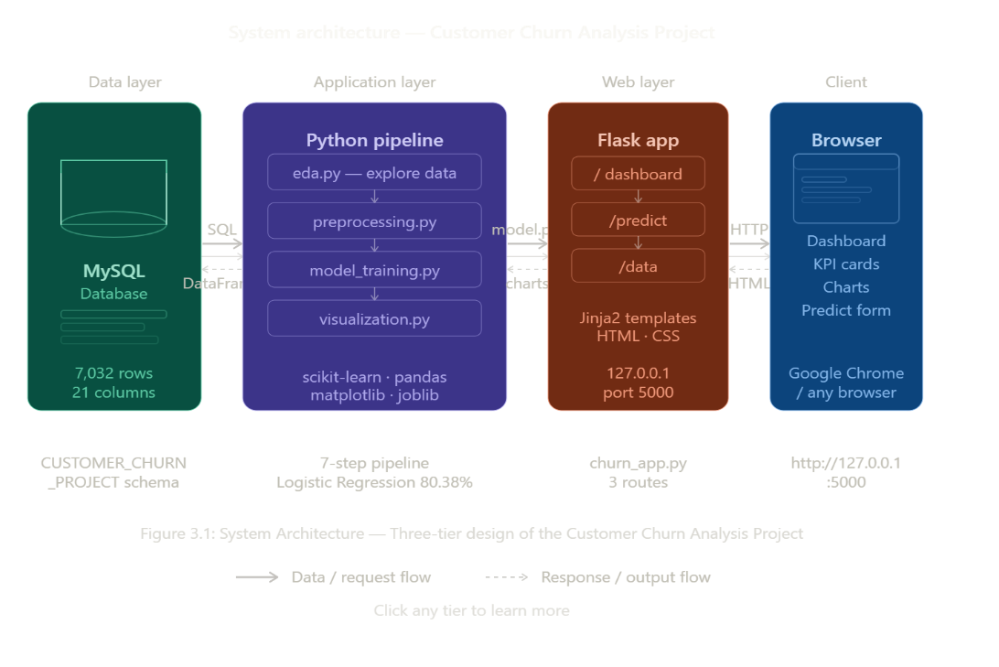

3.2 Data Flow Diagram

Level 0 — Context Diagram
At the highest level of abstraction, the system receives two types of input: the MySQL database (batch customer data for analysis and model training) and web browser user requests (real-time prediction inputs). The system produces two types of output: analytical charts and KPI metrics displayed on the dashboard, and churn probability predictions returned to the user.

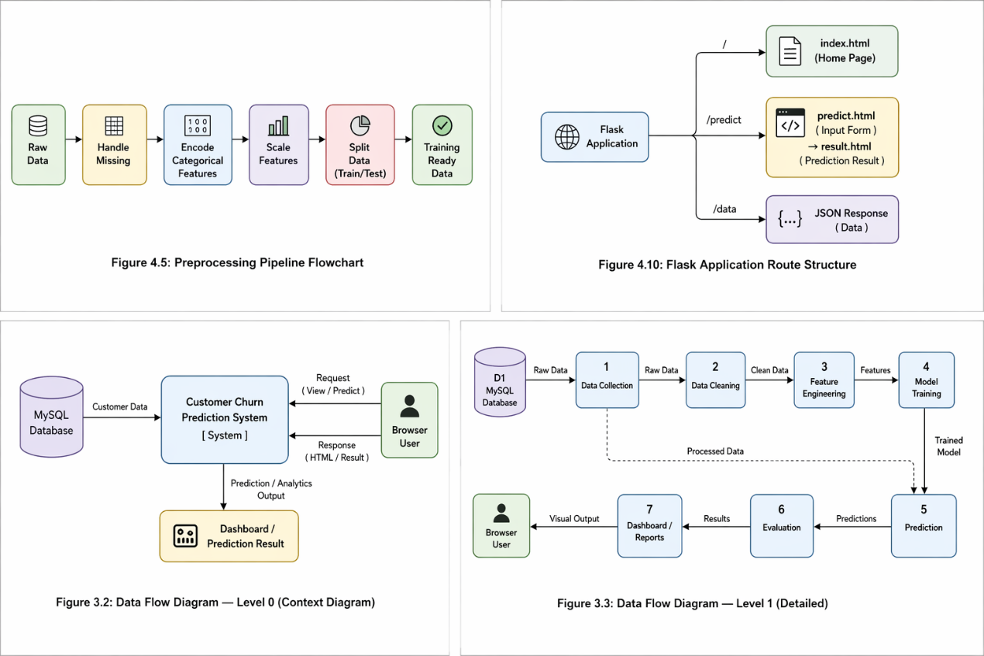
Figure 3.2: Data Flow Diagram — Level 0 (Context Diagram)

Level 1 — Detailed DFD
The Level 1 DFD decomposes the system into seven sequential processes:
- Data Ingestion: Receives raw customer records from MySQL and outputs a clean pandas DataFrame.
- EDA Process: Analyses the DataFrame and outputs exploratory visualisation charts.
- Preprocessing: Transforms the raw DataFrame into a scaled, encoded training matrix.
- Model Training: Receives the prepared matrix and outputs serialised model binary files.
- Evaluation: Receives model files and test data, outputs performance metrics and confusion matrix.
- Visualisation: Receives clean DataFrame and produces four comprehensive analysis PNGs.
- Web Application: Handles browser HTTP requests, queries database and model, returns HTML responses.

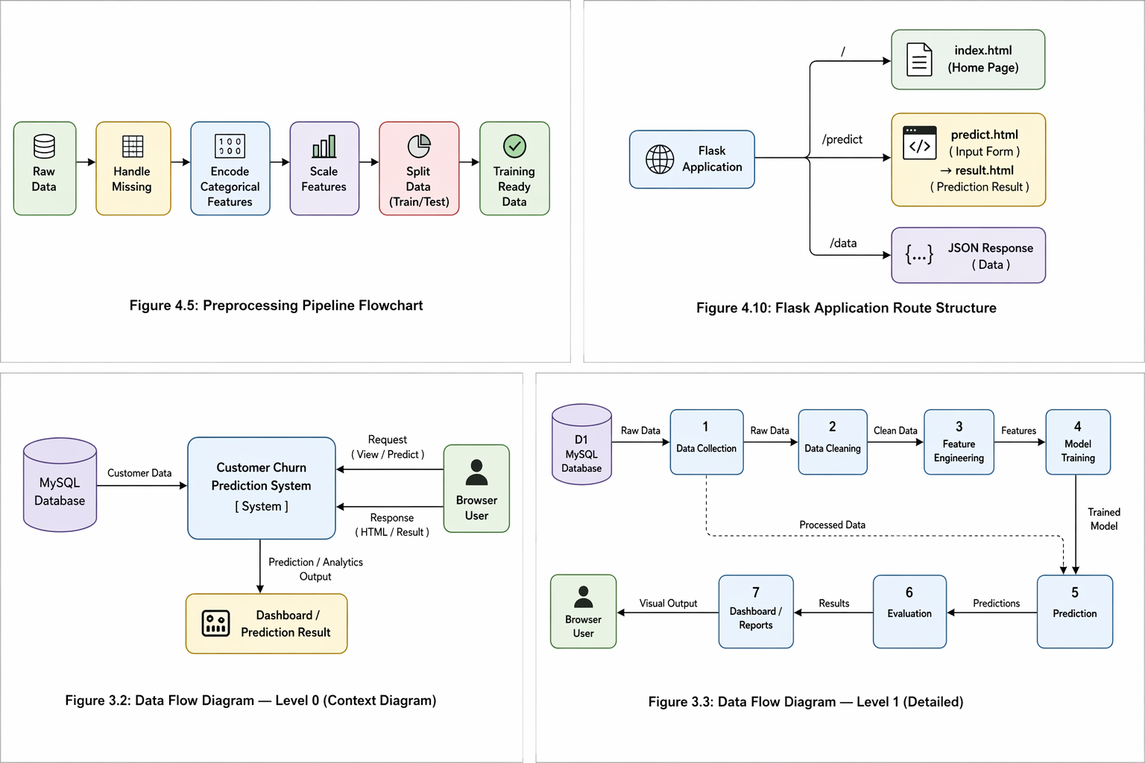
Figure 3.3: Data Flow Diagram — Level 1 (Detailed)

3.3 Database Design

The database consists of a single normalised table — Customers — within the CUSTOMER_CHURN_PROJECT schema. The complete column structure is defined as follows:

Column Name | Data Type | Description
CustomerId | VARCHAR(50) | Unique identifier for each customer record
Gender | VARCHAR(10) | Customer gender: Male or Female
SeniorCitizen | INT | Senior citizen indicator: 0 = No, 1 = Yes
Partner | VARCHAR(10) | Has a partner: Yes or No
Dependents | VARCHAR(10) | Has dependents: Yes or No
Tenure | INT | Number of months as an active customer
PhoneService | VARCHAR(10) | Has phone service subscription: Yes or No
MultipleLines | VARCHAR(50) | Has multiple phone lines subscription
InternetService | VARCHAR(20) | Type of internet: DSL, Fiber optic, or No
OnlineSecurity | VARCHAR(20) | Online security add-on subscription status
OnlineBackup | VARCHAR(20) | Online backup add-on subscription status
DeviceProtection | VARCHAR(20) | Device protection subscription status
TechSupport | VARCHAR(20) | Technical support subscription status
StreamingTV | VARCHAR(20) | Streaming TV subscription status
StreamingMovies | VARCHAR(20) | Streaming movies subscription status
Contract | VARCHAR(20) | Contract type: Month-to-Month, 1 Year, 2 Year
PaperlessBilling | VARCHAR(20) | Paperless billing enabled: Yes or No
PaymentMethod | VARCHAR(50) | Payment method used by the customer
MonthlyCharges | FLOAT | Monthly billing amount charged in USD
TotalCharges | FLOAT | Total cumulative billing amount in USD
Churn | VARCHAR(10) | Target variable: Yes (churned) or No (retained)
Table 3.1: Customers Table — Column Definitions (21 Columns)

3.4 Pipeline Design

Step | Script | Input | Output
1 | sqldatabase_connection.py | MySQL DB | pandas DataFrame (7032 rows)
2 | eda.py | DataFrame | Charts saved to static/
3 | preprocessing.py | DataFrame | Scaled feature matrix + labels
4 | model_training.py | Feature matrix | model.pkl, scaler.pkl, feature_names.pkl
5 | model_evaluating.py | model.pkl + test set | Accuracy report, confusion_matrix.png
6 | visualization.py | DataFrame | 4 analysis chart PNGs in static/
7 | churn_app.py | HTTP requests | HTML pages + JSON responses
Table 3.2 Pipeline Design

Chapter 4
Implementation
4.1 Development Environment and Project Structure

The project was developed on a Windows 11 machine using Visual Studio Code (VS Code) as the Integrated Development Environment. Python 3.11 was used as the programming language with Flask 3.x for web development, and MySQL Server 8.0 for database management.
Library / Tool | Version | Purpose
Python | 3.11 | Core programming language
Flask | 3.x | Web application framework
mysql-connector-python | 8.x | Python to MySQL connector
Pandas | 2.x | Data loading and manipulation
Numpy | 1.x | Numerical operations
scikit-learn | 1.x | ML model training and evaluation
Matplotlib | 3.x | Chart and plot generation
Seaborn | 0.x | Statistical visualisation styling
Joblib | 1.x | Model serialisation and loading
Jinja2 | 3.x | HTML template rendering
MySQL Server | 8.0 | Relational database management
VS Code | Latest | Integrated development environment
Table 4.1: Software Dependencies and Versions
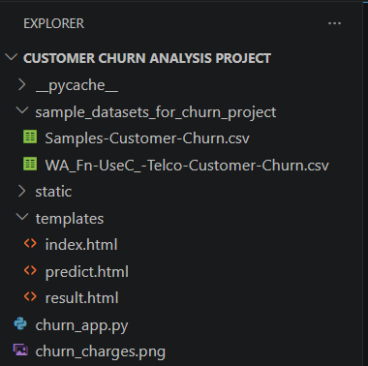
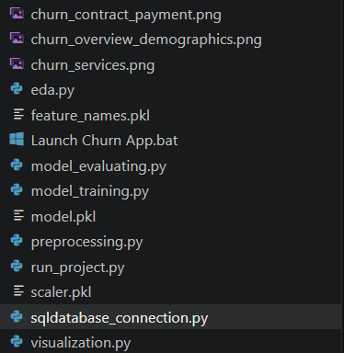
Figure 4.1: Project File Structure in VS Code

4.2 Database Connection Module

The sqldatabase_connection.py module establishes the connection between Python and the MySQL database. The load_data() function serves as the single interface used by all pipeline modules and the Flask application to retrieve customer records.
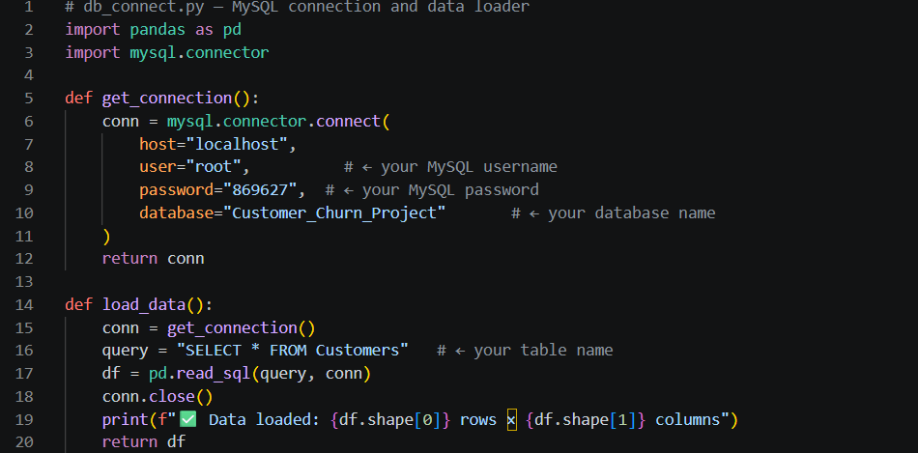

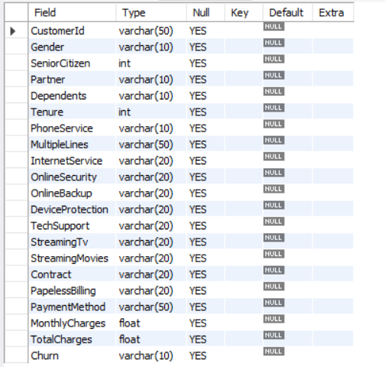
Figure 4.2: MySQL Workbench — Customers Table Schema

4.3 Exploratory Data Analysis

The eda.py module performs the initial statistical and visual exploration of the customer dataset to understand its structure, identify anomalies, and formulate hypotheses about the drivers of churn.
4.3.1 Dataset Summary Statistics
Feature | Mean | Std Dev | Min | Max
Tenure (months) | 32.37 | 24.56 | 0 | 72
MonthlyCharges ($) | 64.76 | 30.09 | 18.25 | 118.75
TotalCharges ($) | 2283.30 | 2266.77 | 18.80 | 8684.80
SeniorCitizen (0/1) | 0.162 | 0.369 | 0 | 1
Table 4.2: Dataset Summary Statistics
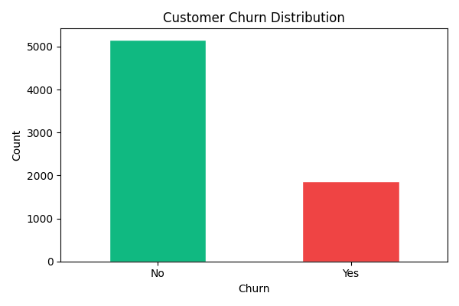
Figure 4.3: Churn Distribution Chart (eda.py output)

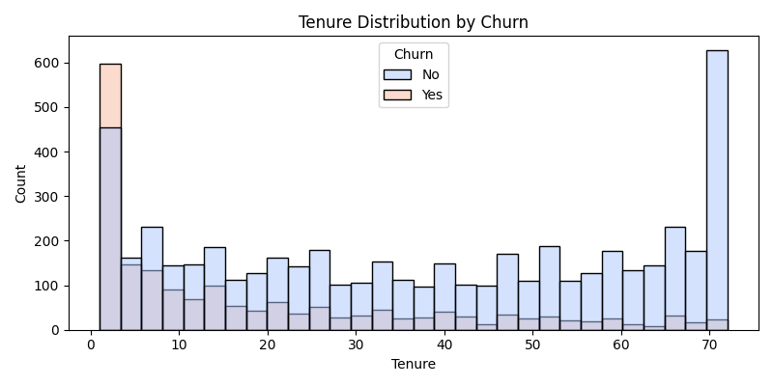
Figure 4.4: Tenure Distribution Histogram by Churn

4.3.2 Key EDA Observations
- The dataset has a class imbalance: 73.5% of customers are retained (5,174 records) and 26.5% have churned (1,869 records).
- Customers with shorter tenure (0–12 months) exhibit significantly higher churn rates, suggesting early-stage retention is most critical.
- A positive correlation exists between MonthlyCharges and churn probability.
- The TotalCharges column contained 11 missing values corresponding to new customers with zero tenure, handled during preprocessing.
- Fiber Optic internet users churn at 41.9% — more than double the rate of DSL users (19.0%).

4.4 Data Preprocessing

The preprocessing.py module transforms the raw dataset into a format ready for machine learning model training through four sequential stages.
4.4.1 Missing Value Treatment.
# Convert TotalCharges to numeric (11 empty strings become NaN) df['TotalCharges'] = pd.to_numeric(df['TotalCharges'], errors='coerce')
df.dropna(inplace=True)
# Result: 7,032 clean rows (removed 11 invalid records)


Figure 4.5: Preprocessing Pipeline Flowchart

4.4.2 Categorical Encoding
Column | Method | Example Values
Gender | Label Encoding | Female=0, Male=1
Partner | Label Encoding | No=0, Yes=1
InternetService | Label Encoding | DSL=0, Fiber optic=1, No=2
Contract | Label Encoding | Month-to-month=0, One year=1, Two year=2
PaymentMethod | Label Encoding | Bank transfer=0, Credit card=1, ...
Churn (target) | Binary Mapping | No=0, Yes=1
Table 4.3: Categorical Columns and Encoding Strategy
4.4.3 Train-Test Split and Feature Scaling
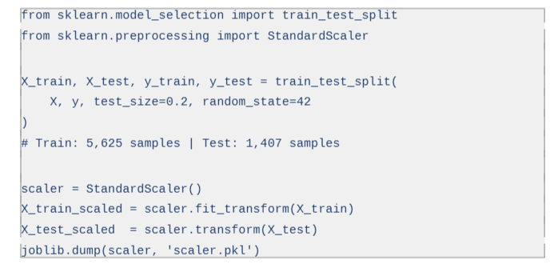
4.5 Model Training and Selection

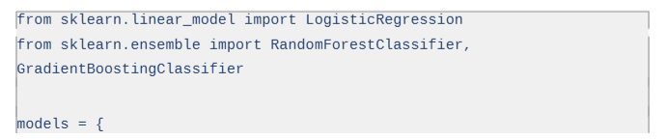
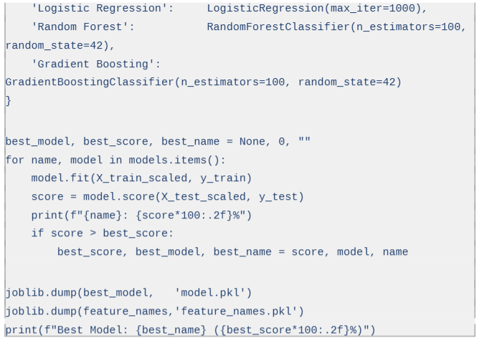
The model_training.py module trains, evaluates, and selects the best-performing classification algorithm from among three candidates.

Model | Accuracy | Status | Saved As
Logistic Regression | 80.38% | SELECTED | model.pkl
Gradient Boosting Classifier | 79.53% | Not selected | —
Random Forest Classifier | 78.68% | Not selected | —
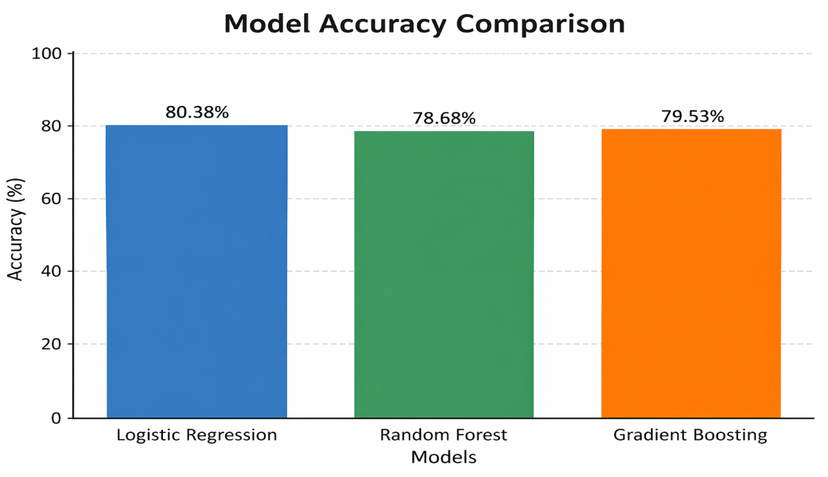
Table 4.4: Machine Learning Model Accuracy Comparison
Figure 4.6: Model Accuracy Comparison Chart

4.6 Model Evaluation

The model_evaluating.py module performs comprehensive evaluation of the selected Logistic Regression model on the held-out test set of 1,407 samples.

Class | Precision | Recall | F1-Score | Support
0 — Not Churned | 0.85 | 0.89 | 0.87 | 1,033
1 — Churned | 0.65 | 0.57 | 0.61 | 374
Macro Average | 0.75 | 0.73 | 0.74 | 1,407
Weighted Average | 0.80 | 0.80 | 0.80 | 1,407
Table 4.5: Classification Report — Logistic Regression

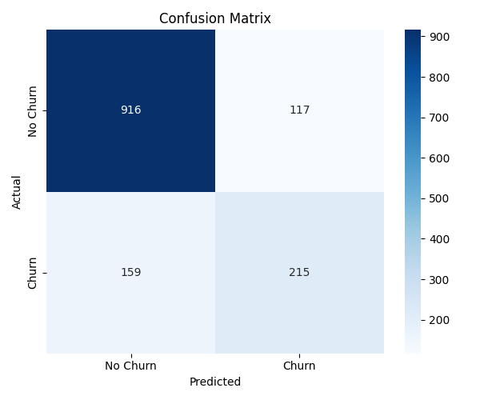
Figure 4.7: Confusion Matrix — Logistic Regression

4.7 Visualisation Module

The visualization.py module generates four multi-panel analysis figures saved as PNG files to the static/ directory for display on the Flask dashboard.
- churn_overview_demographics.png: 2×3 panel — overall churn pie chart, churn by gender, senior citizen, partner, dependents, and tenure histogram.
- churn_services.png: 3×3 panel — churn rates for all nine service subscription columns.
- churn_contract_payment.png: 1×3 panel — churn by contract type, paperless billing, and payment method.
- churn_charges.png: 1×3 panel — monthly charges box plot, total charges box plot, and tenure vs charges scatter plot.

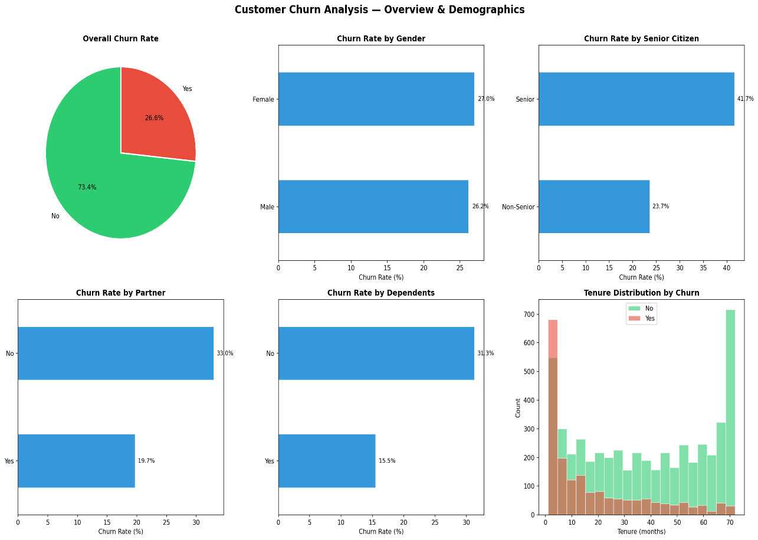
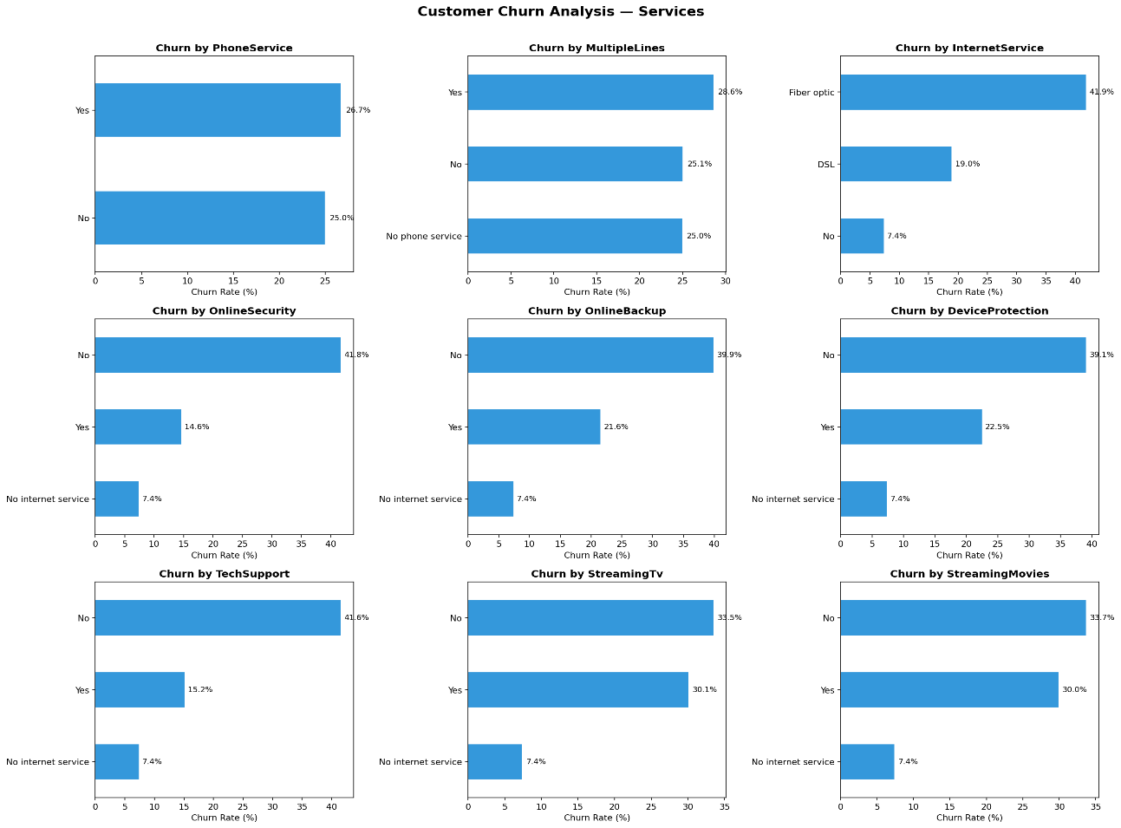
Figure 4.8: Churn Overview and Demographics Chart
Figure 4.9: Churn by Services Chart
4.8 Flask Web Application

The churn_app.py module implements the Flask web application with three routes, loading the trained model at startup.
4.8.1 Route 1 — Dashboard (GET /)
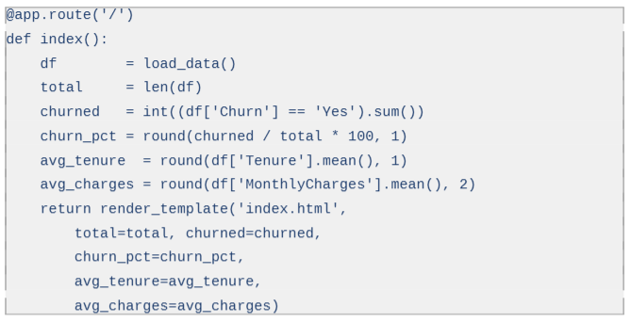
4.8.2 Route 2 — Prediction (GET/POST /predict)
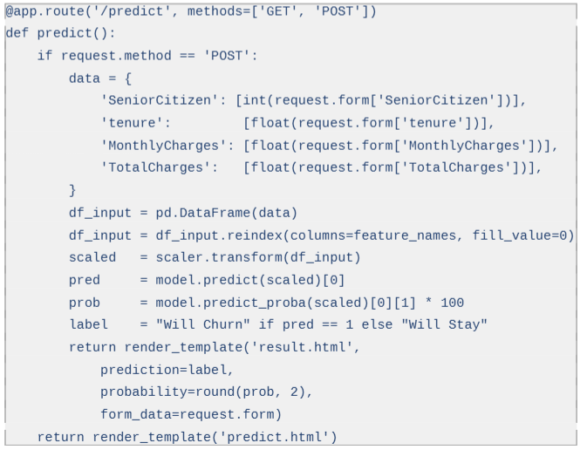

Figure 4.10: Flask Application Route Structure

Chapter 5
Results and Analysis

5.1 Model Performance Results

The machine learning component was evaluated using accuracy, precision, recall, and F1-score. The Logistic Regression model achieved the highest overall accuracy of 80.38% on the test set and was deployed within the Flask web application.

The model's performance on the churned class (class 1) reflects the inherent class imbalance in the dataset. A precision of 0.65 means 65% of all customers predicted to churn actually do. A recall of 0.57 means the model correctly identifies 57% of all actual churners. The F1-score of 0.61 represents the harmonic mean, providing a balanced performance measure for the imbalanced class.

The model demonstrates strong ability to identify non-churning customers (F1 = 0.87) which is equally important for business operations — avoiding unnecessary retention offers to customers who would have stayed regardless.

5.2 Key Analytical Findings

5.2.1 Churn by Contract Type
Contract Type | Customers | Churned | Churn Rate
Month-to-Month | 3,875 | 1,655 | 42.7%
One Year | 1,473 | 166 | 11.3%
Two Year | 1,695 | 48 | 2.8%
Table 5.1: Churn Rate by Contract Type

Month-to-month customers churn at 42.7% — fifteen times the rate of two-year contract holders (2.8%). This is the single strongest predictor of churn identified in the analysis. Incentivising customers to commit to longer contracts would be the highest-impact retention strategy available.

5.2.2 Churn by Payment Method
Payment Method | Customers | Churned | Churn Rate
Electronic Check | 2,365 | 1,071 | 45.3%
Mailed Check | 1,612 | 308 | 19.1%
Bank Transfer (Automatic) | 1,544 | 258 | 16.7%
Credit Card (Automatic) | 1,522 | 232 | 15.2%
Table 5.2: Churn Rate by Payment Method

5.2.3 Churn by Demographics
Factor | Group | Churn Rate | Business Insight
Senior Citizen | Senior | 41.7% | Nearly double the baseline rate
Senior Citizen | Non-Senior | 23.6% | Baseline churn rate
Partner | No Partner | 33.0% | Higher without partner
Partner | Has Partner | 20.0% | Partner reduces churn risk
Dependents | No Dependents | 31.3% | Higher mobility
Dependents | Has Dependents | 15.5% | Family obligations reduce churn
Table 5.3: Churn Rate by Demographics

5.3 Web Application Screenshots

5.3.1 Dashboard Page

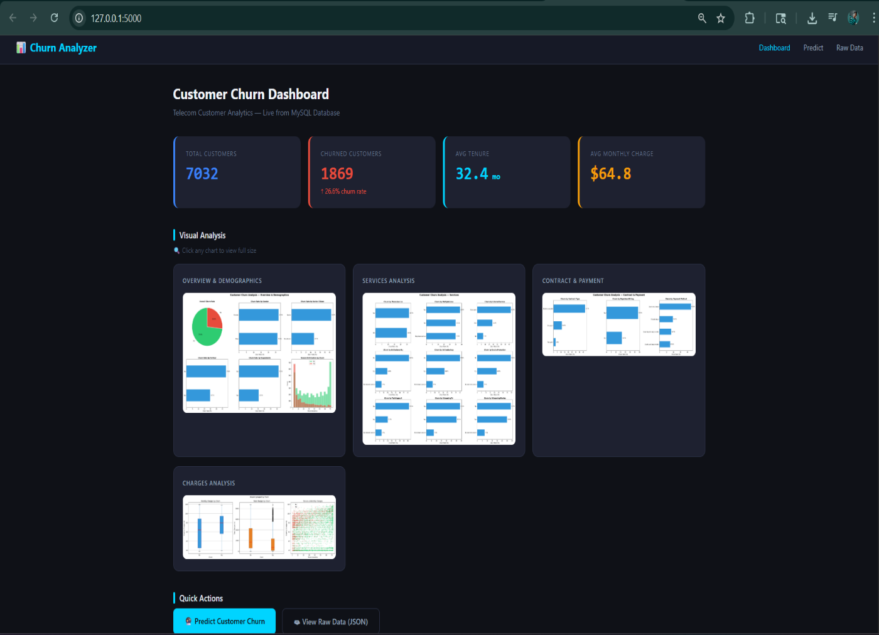Figure 5.1: Flask Dashboard — KPI Metric Cards

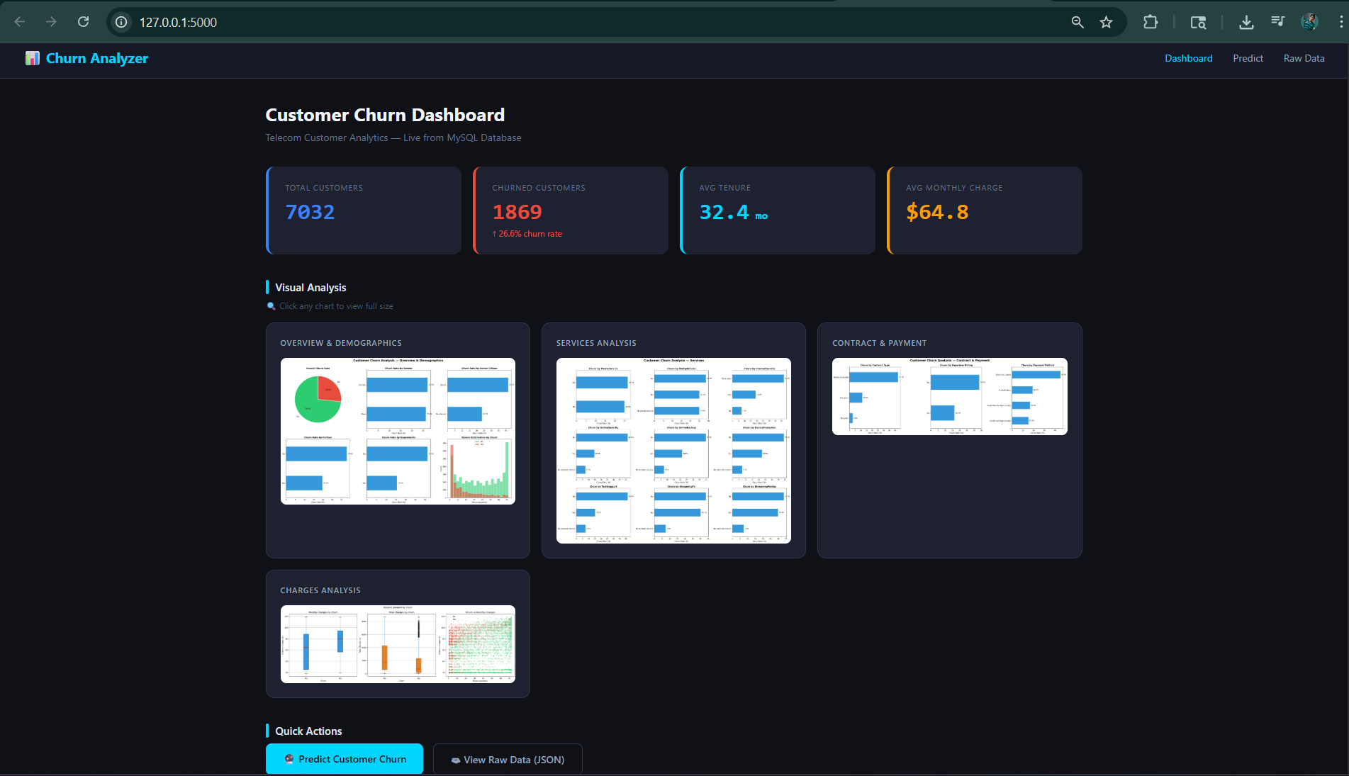
Figure 5.2: Flask Dashboard — Visual Analysis Charts

5.3.2 Prediction Pages

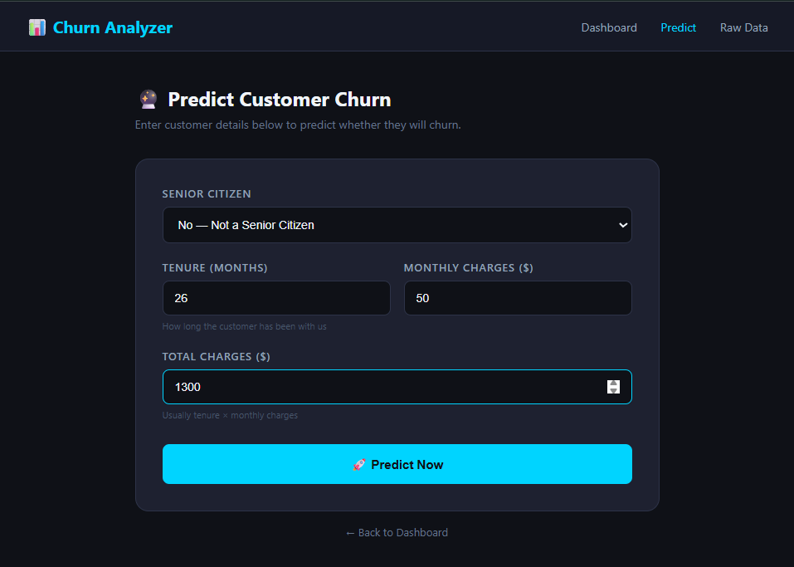
Figure 5.3: Prediction Form Page (/predict)

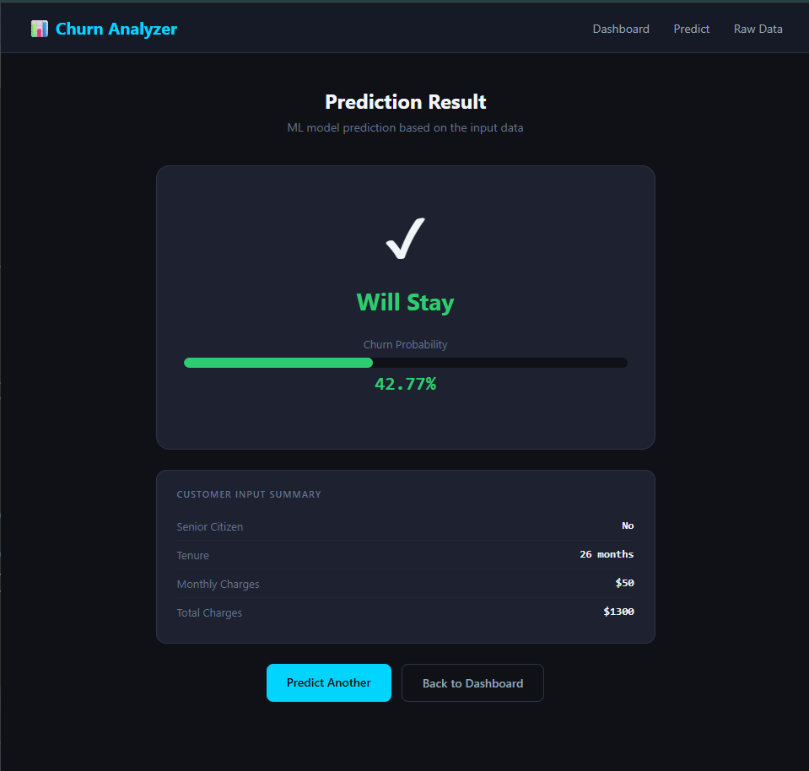
Figure 5.4: Prediction Result Page with Probability Bar

Chapter 6
Conclusion and Future Scope

6.1 Conclusion

This project has successfully demonstrated the design, development, and deployment of a complete end-to-end customer churn analysis and prediction system for the telecommunications domain. Developed as the BCA 6th Semester Major Project, the system integrates a MySQL relational database, a Python data science pipeline, three machine learning classification models, and a Flask web application into a cohesive, functional solution.

All primary technical objectives have been fully achieved. The best-performing machine learning model — Logistic Regression — achieves an accuracy of 80.38% on the held-out test set. The Flask web application successfully provides a live analytics dashboard with KPI metrics and four comprehensive analysis charts, a real-time individual customer churn prediction interface, and a programmatic JSON data endpoint.

The analytical component has yielded several important and actionable business findings. Month-to-month contract customers exhibit a churn rate of 42.7% compared to just 2.8% for two-year contract holders — representing the single strongest predictor of churn. Senior citizens churn at 41.7%, nearly double the rate of non-senior customers. Electronic cheque users churn at 45.3%, significantly higher than customers using automatic payment methods. These findings provide clear, data-driven guidance for targeted retention strategy development.

The modular architecture of the codebase ensures that the system can be readily adapted for churn analysis in other industries — banking, insurance, or subscription services — by replacing the data source and updating column references in each module. The entire solution is built using open-source tools, demonstrating that production-grade data science applications can be developed without commercial platforms.

This project has also provided valuable hands-on experience with the complete data science lifecycle — from database design and exploratory analysis through machine learning deployment and web application development — significantly enhancing the technical competencies relevant to a career in data science or software development.

6.2 Limitations

- The prediction interface accepts only four input features. Full utilisation of all 19 features would improve prediction accuracy but requires a more comprehensive form design.
- The model does not implement class rebalancing techniques such as SMOTE, which limits recall on the minority churned class (currently 0.57).
- The application is currently deployed locally (localhost) and is not publicly accessible without cloud hosting.
- The trained model is static and does not automatically retrain as new customer data accumulates over time.
- The dataset is a public benchmark (IBM Telco) and may not perfectly represent actual customer behaviour patterns in the Indian telecom market.

6.3 Future Scope

Enhancement | Description
Cloud Deployment | Deploy the application to PythonAnywhere or Render.com with a cloud-hosted MySQL database, providing a public URL for access from any device.
Full Feature Prediction Form | Expand the prediction interface to accept all 19 feature inputs, improving model accuracy and user experience.
Class Rebalancing | Implement SMOTE or class_weight='balanced' during model training to improve recall on the churned minority class.
Advanced ML Models | Evaluate XGBoost, LightGBM, and neural network architectures for potential accuracy improvements beyond 80.38%.
Automated Retraining | Implement a scheduled retraining pipeline using cron or Apache Airflow that updates the model monthly as new customer data is collected.
Batch CSV Prediction | Add a file upload endpoint enabling users to upload a CSV of customer records and receive bulk churn predictions in a single operation.
Streamlit Analytics | Integrate a Streamlit dashboard for richer, interactive analytics with filterable charts and drill-down capabilities.
User Authentication | Implement login/logout using Flask-Login to secure the dashboard and prediction interface from unauthorised access.
Table 6.1: Future Enhancements Roadmap

References

- IBM Corporation. (2019). Telco Customer Churn Dataset. Kaggle Open Dataset. https://www.kaggle.com/datasets/blastchar/telco-customer-churn
- Pedregosa, F., Varoquaux, G., et al. (2011). Scikit-learn: Machine Learning in Python. Journal of Machine Learning Research, 12, 2825–2830.
- McKinney, W. (2010). Data Structures for Statistical Computing in Python. Proceedings of the 9th Python in Science Conference, 51–56.
- Geron, A. (2022). Hands-On Machine Learning with Scikit-Learn, Keras, and TensorFlow (3rd ed.). O'Reilly Media.
- Grinberg, M. (2018). Flask Web Development: Developing Web Applications with Python (2nd ed.). O'Reilly Media.
- Hunter, J. D. (2007). Matplotlib: A 2D Graphics Environment. Computing in Science and Engineering, 9(3), 90–95.
- Waskom, M. L. (2021). Seaborn: Statistical Data Visualization. Journal of Open Source Software, 6(60), 3021.
- DuBois, P. (2013). MySQL Cookbook: Solutions for Database Developers and Administrators (3rd ed.). O'Reilly Media.
- Burez, J., & Van den Poel, D. (2007). CRM at a Pay-TV Company. Expert Systems with Applications, 32(2), 277–288.
- Neslin, S. A., Gupta, S., et al. (2006). Defection Detection. Journal of Marketing Research, 43(2), 204–211.
- Mozer, M. C., et al. (2000). Predicting Subscriber Dissatisfaction. IEEE Transactions on Neural Networks, 11(3), 690–696.
- Amin, A., et al. (2019). Customer Churn Prediction in Telecommunication Industry. Journal of Business Research, 94, 290–301.
- Breiman, L. (2001). Random Forests. Machine Learning, 45(1), 5–32.
- VanderPlas, J. (2016). Python Data Science Handbook. O'Reilly Media. https://jakevdp.github.io/PythonDataScienceHandbook/
- Coussement, K., & Van den Poel, D. (2008). Churn Prediction in Subscription Services. Expert Systems with Applications, 34(1), 313–327.

Appendices

Appendix A How to Run the Project
Follow these steps to run the complete project from scratch on a Windows machine:
- Install Python 3.11 from https://python.org and MySQL Server 8.0 from https://dev.mysql.com
- Install all required libraries in the VS Code terminal
pip install flask pandas numpy scikit-learn matplotlib seaborn mysql-connector-python joblib
- Open MySQL Workbench, create the CUSTOMER_CHURN_PROJECT database and Customers table, then import the IBM Telco CSV.
- Open the project folder in VS Code and update your database credentials in sqldatabase_connection.py.
- Double-click the Launch Churn App.bat desktop shortcut (or run python run_project.py in terminal).
- Open Chrome and navigate to http://127.0.0.1:5000

Appendix B Dataset Information
Dataset: IBM Telco Customer Churn | Source: Kaggle (https://www.kaggle.com/datasets/blastchar/telco-customer-churn) | Records: 7,043 customers | Columns: 21 attributes | License: Open Data Commons ODbL | Files used: WA_Fn-UseC_-Telco-Customer-Churn.csv

Appendix C Glossary of Technical Terms
Term | Definition
Churn | The discontinuation of a service subscription by a customer.
Classification | Supervised ML task predicting a discrete class label.
Confusion Matrix | Table showing TP, FP, TN, and FN for a classifier.
F1-Score | Harmonic mean of precision and recall; balanced performance metric.
Feature Scaling | Normalising numerical features to a common range.
Flask | Lightweight Python web framework for building web applications.
Gradient Boosting | Sequential ensemble ML method correcting prior model errors.
Jinja2 | Python templating engine used by Flask for dynamic HTML.
Label Encoding | Converting categorical string values to integer representations.
Logistic Regression | Linear model estimating probability of binary class membership.
MySQL | Relational database management system using SQL.
Pandas | Python library for data manipulation using DataFrame structures.
Precision | Proportion of positive predictions that are actually correct.
Random Forest | Ensemble of decision trees trained on bootstrapped data subsets.
Recall | Proportion of actual positives correctly predicted as positive.
Scikit-learn | Python library providing ML algorithms and evaluation tools.
StandardScaler | Preprocessor standardising features to zero mean and unit variance.

— End of Major Project Report —

